Step 1 :
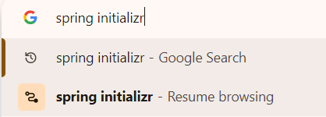

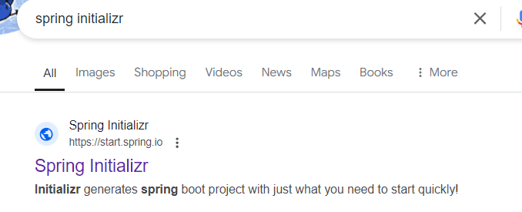

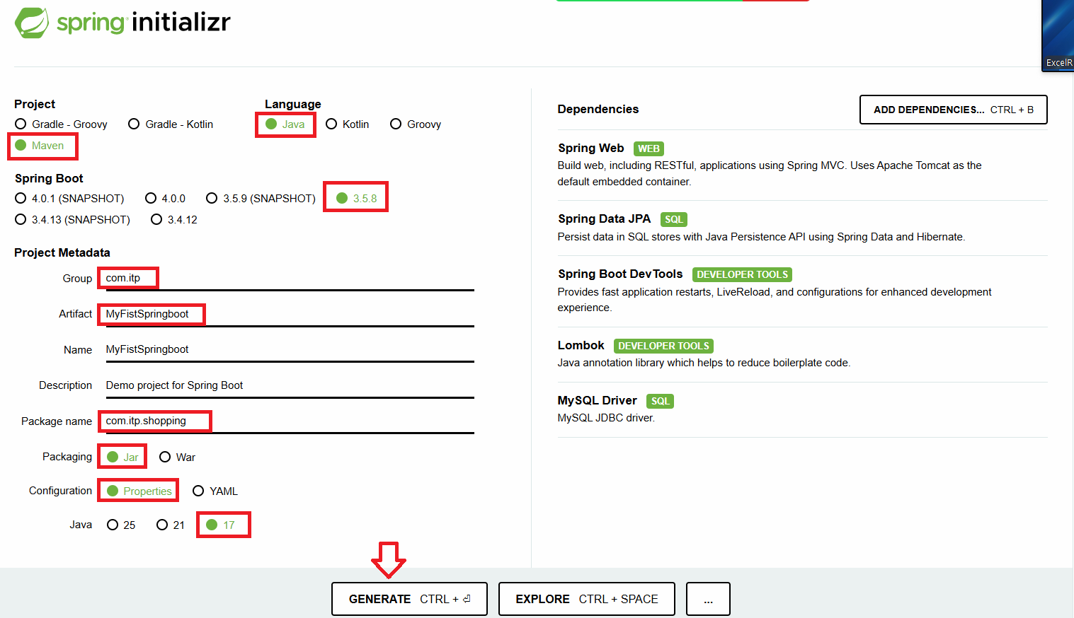
Once you click on GENERATE , it will download a jar file into the downloads folder

Step 2 :
Extract the downloaded jar file (use winrar)
Copy the extracted folder and paste in your eclipse workspace

Step 3 :
Open the project in eclipse
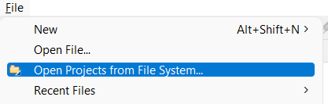

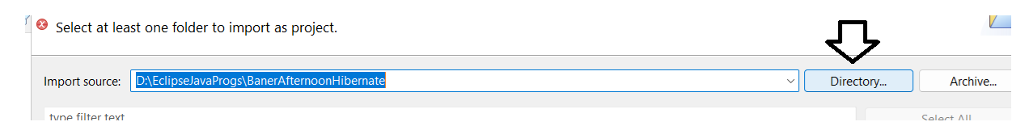
Browse for the pasted folder on the hard disk and add it
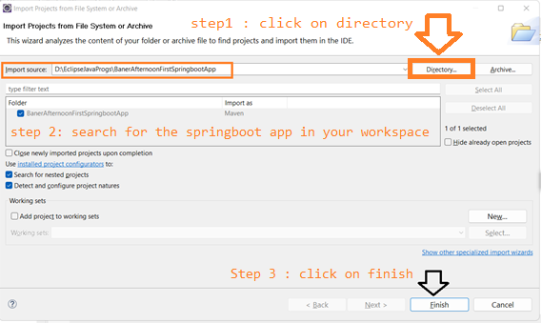
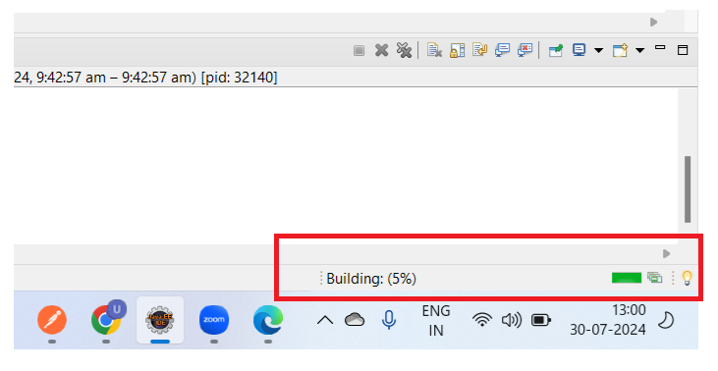
Note : After finishing pls make sure that the bottom right progress bar completes, don’t do anything before the completion of the progressbar(for the first app it might take some time)
Note : Pls have a stable internet connection at this time.

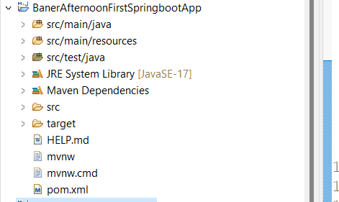
The application will reflect in eclipse now.

